Aws project Screenshots
Vpc creation:
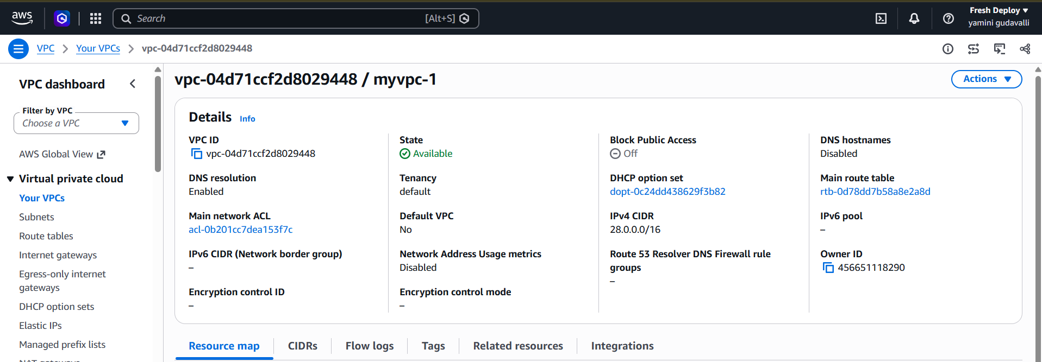
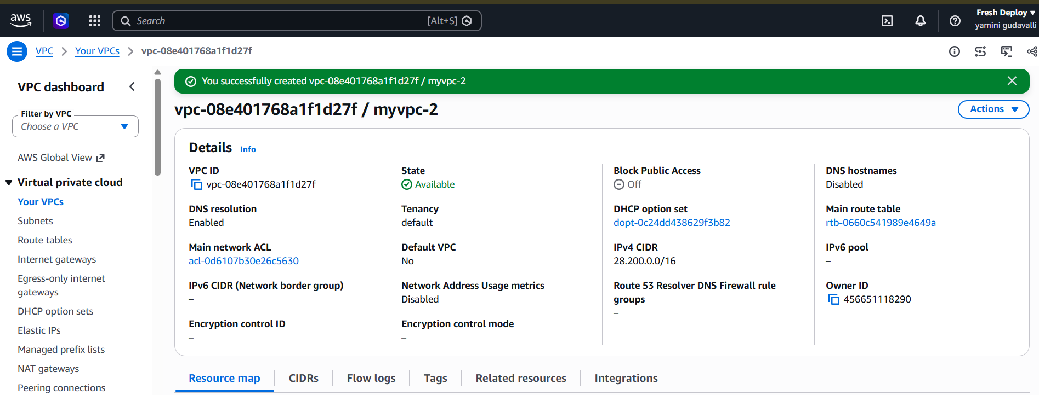

02-subnet-creation.png

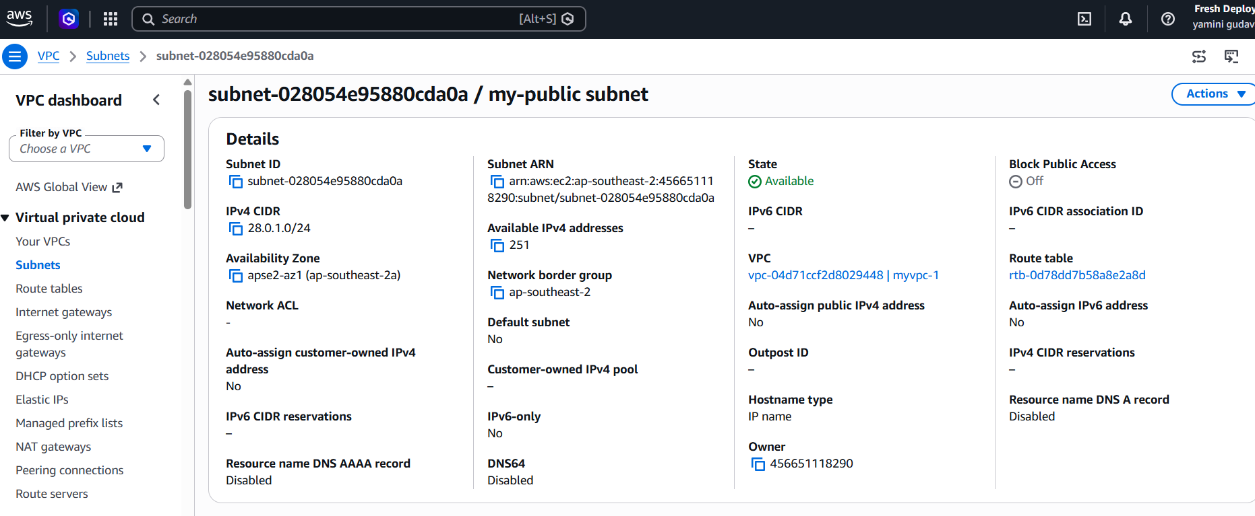
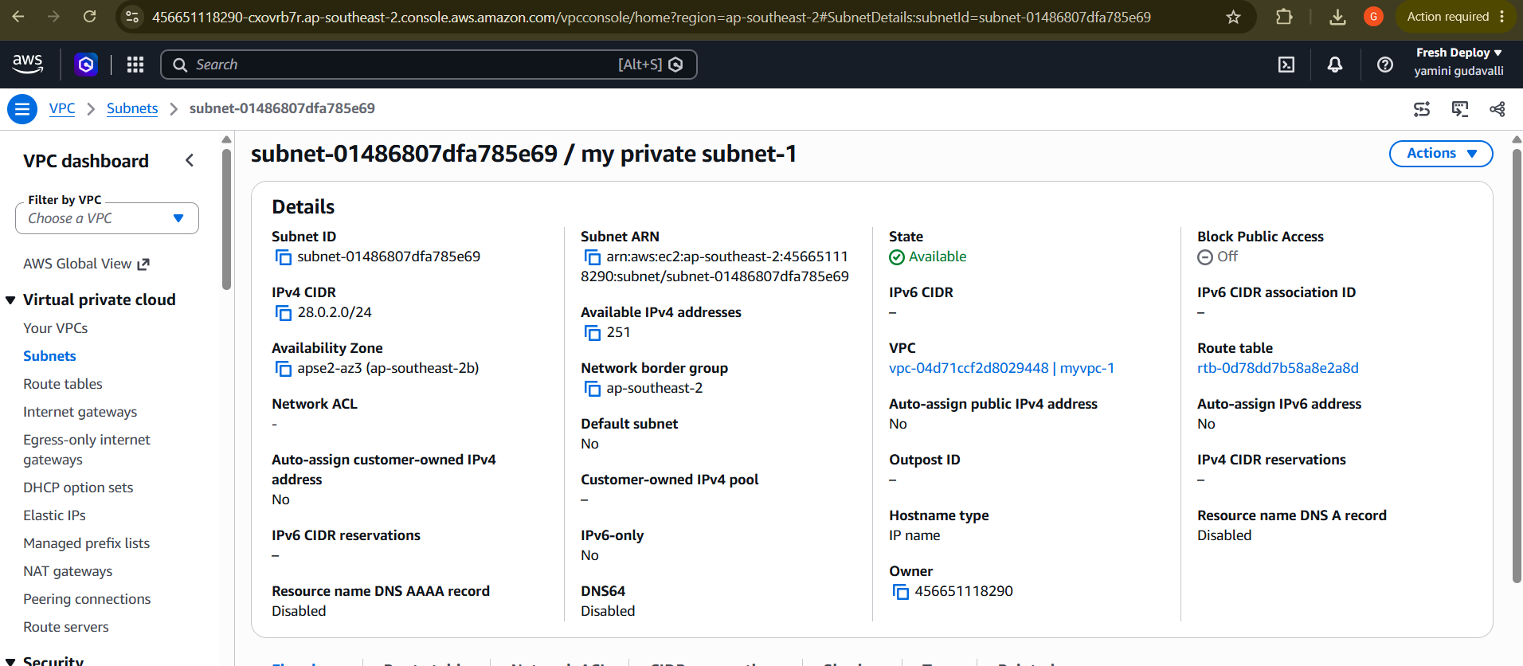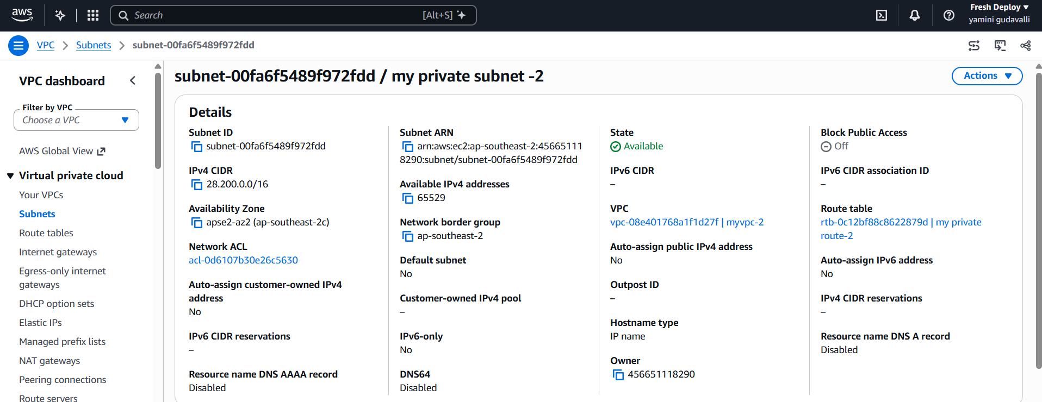

03-internet-gateway.png:
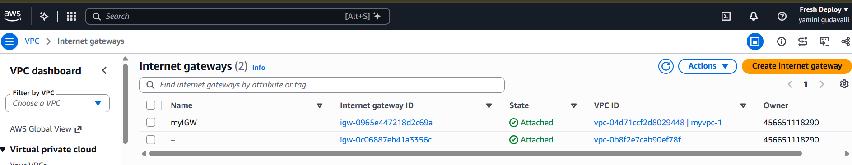

04-public-route-table.png:

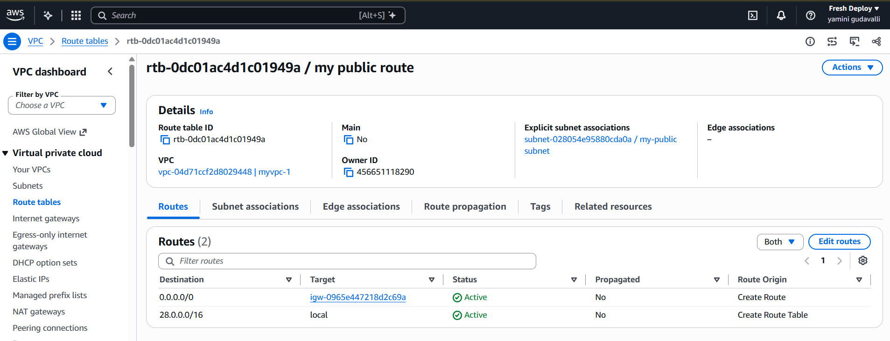
05-private-route-table.png :
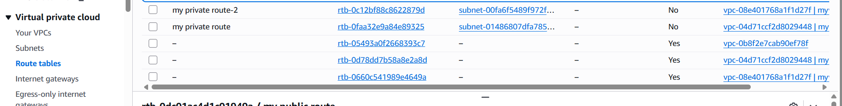

06-vpc-peering.png :
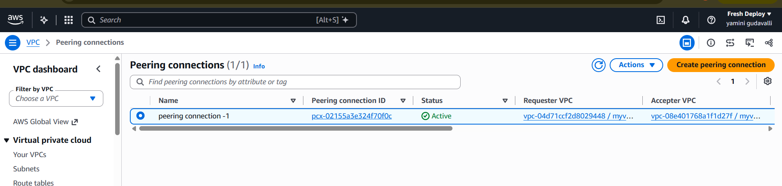

07-security-groups.png:
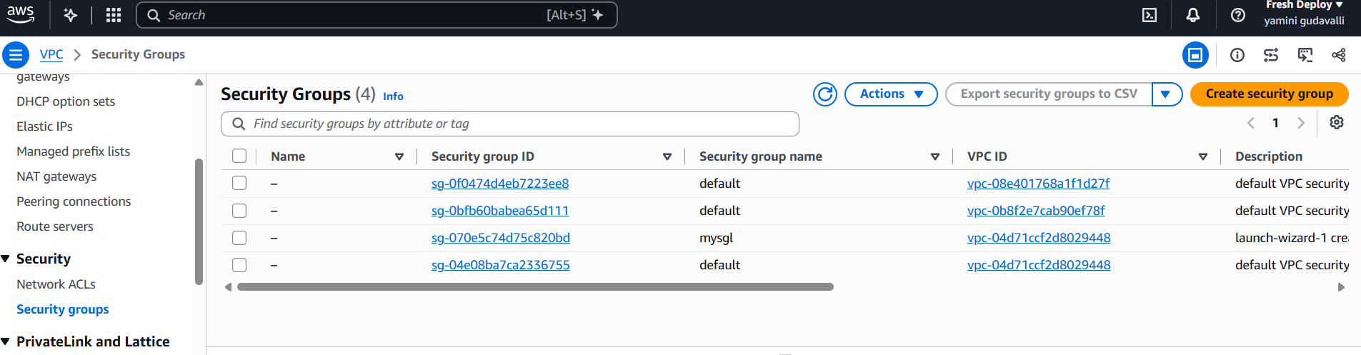

08-ec2-instances.png:
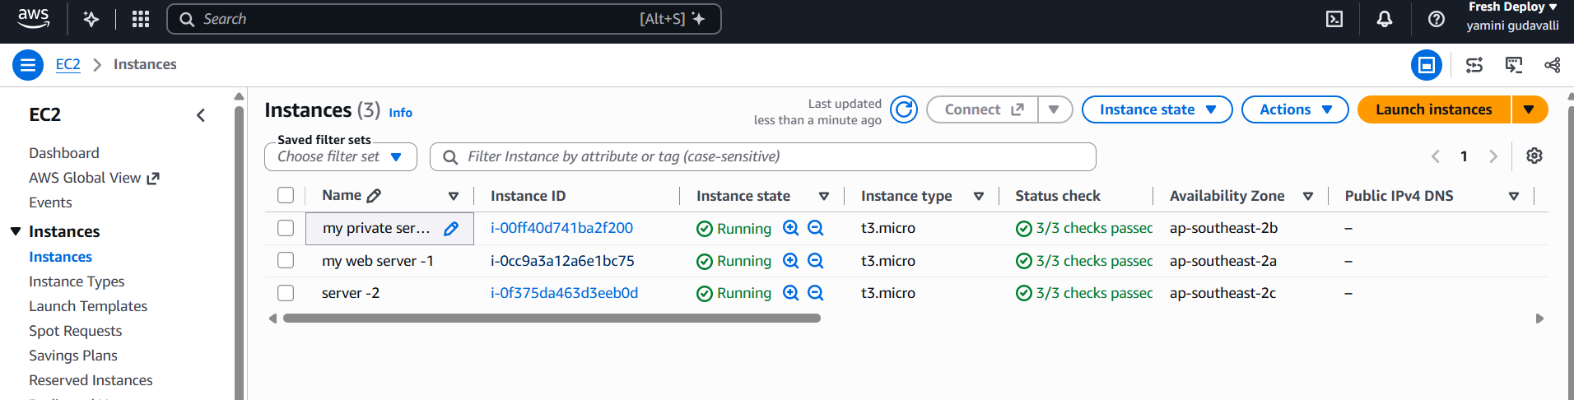

connectivity-testing.png:


